SPRINT 3

Check the Project:
WOKWI SIMULATOR LINK : https://wokwi.com/projects/348396627523797588
WEB UI LINK : https://node-red-dashboard059.eu-gb.mybluemix.net/fire
Results:
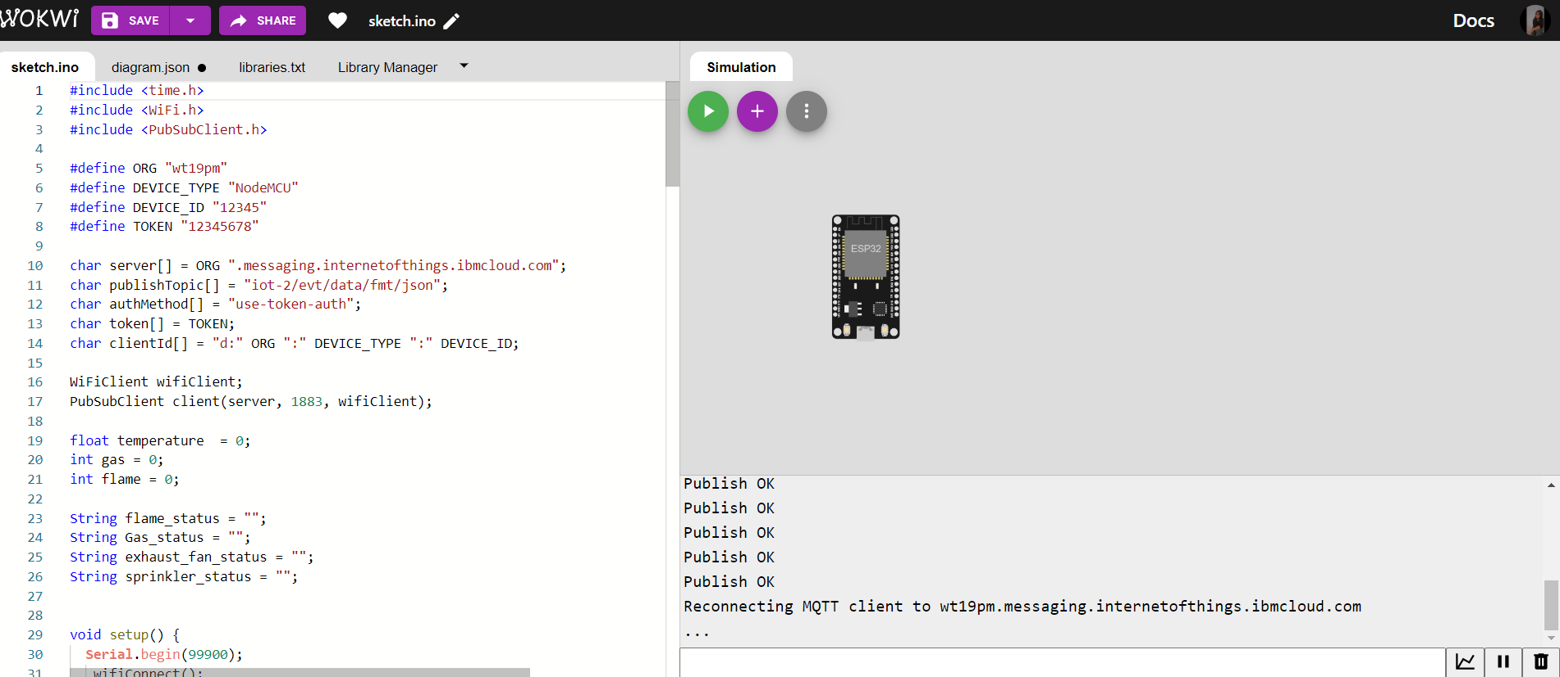

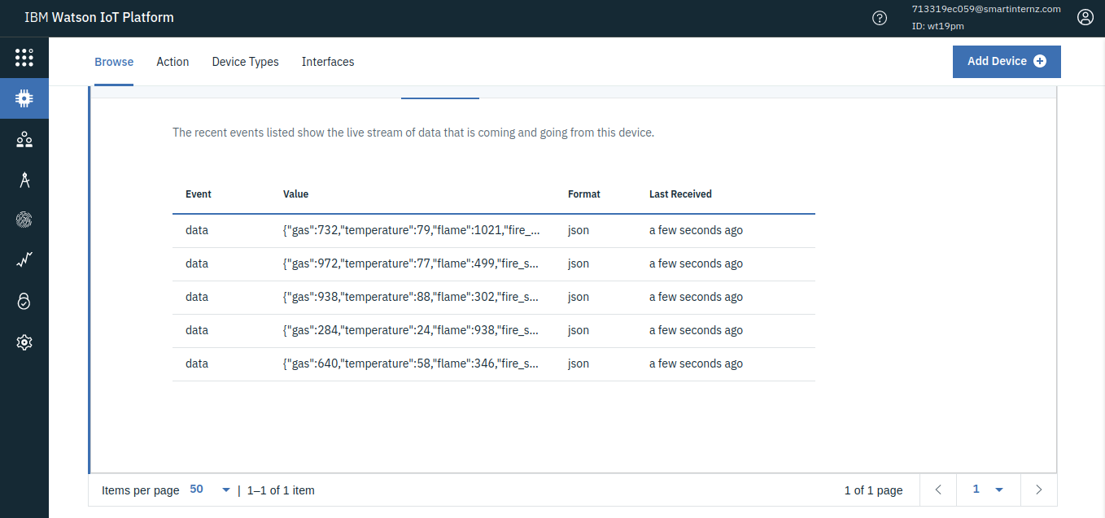

TRANSFERRING DATA FROM IBM WATSON INTO NODE-RED:
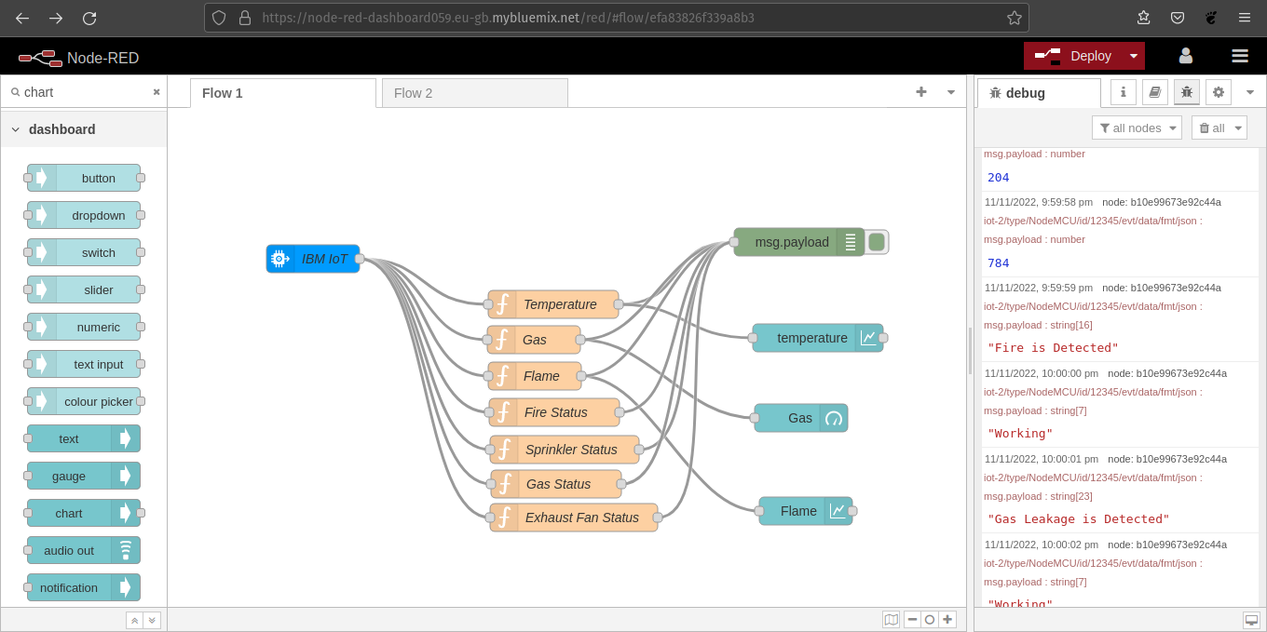

NODE-RED DASHBOARD:

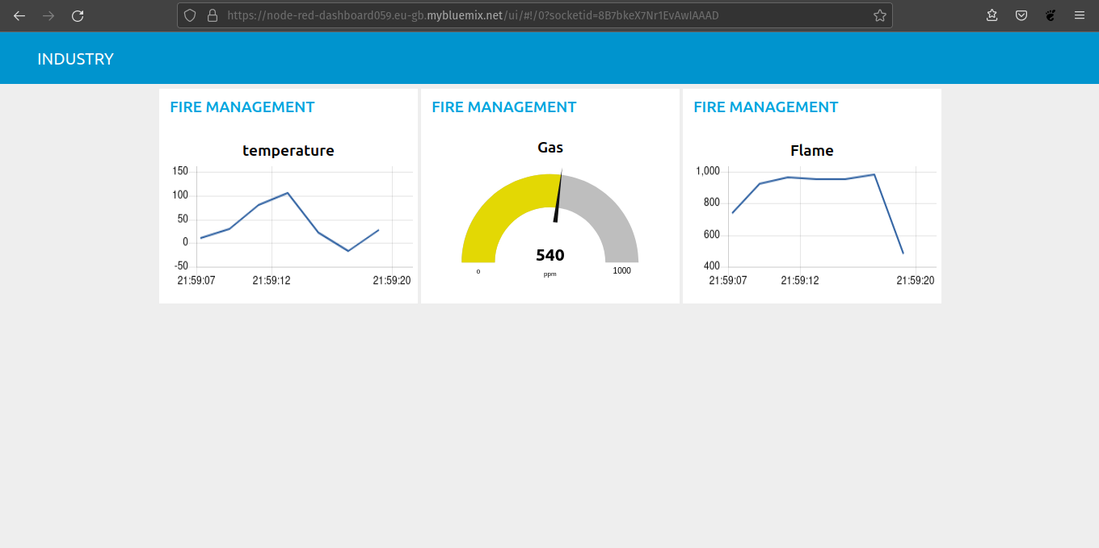

TRANSFERRING DATA FROM NODE-RED INTO WEB PAGE USING WEB SOCKET:

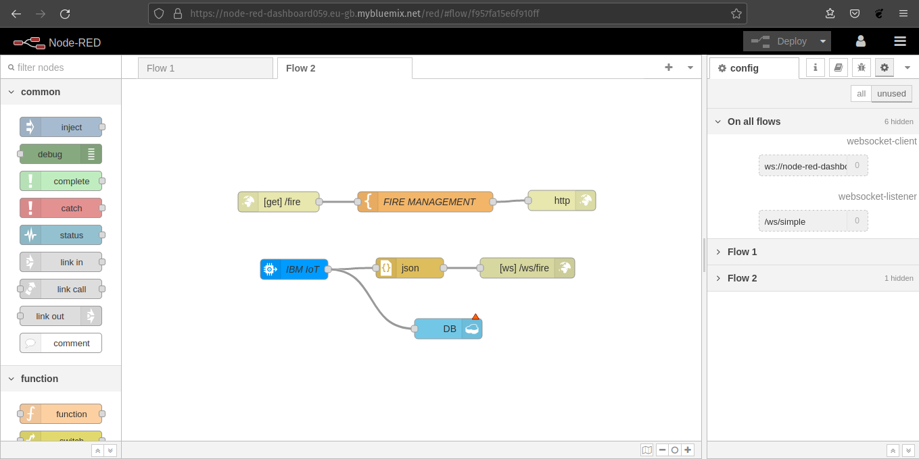

WEB UI:
DESKTOP VIEW

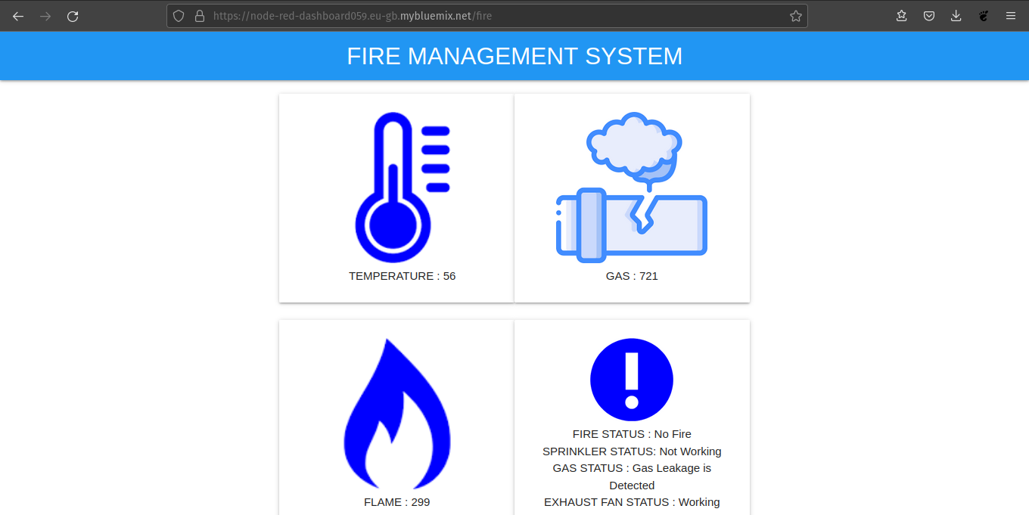

MOBILE VIEW:

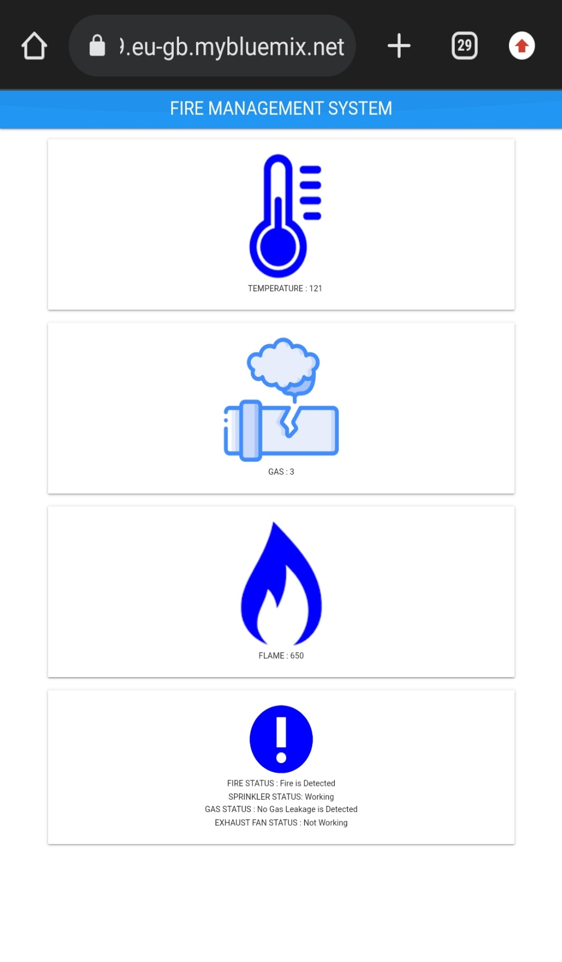

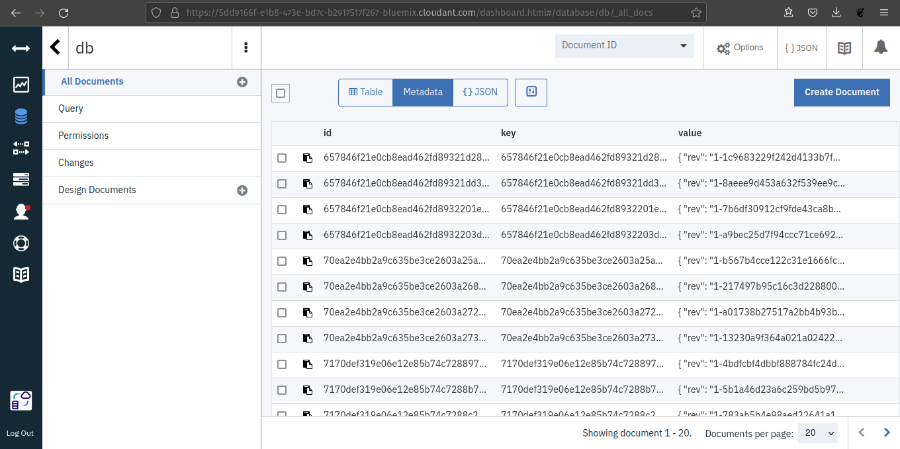
CLOUDANT:

